 | Filing Reference : |  | GG/COMS/TS.2/6
 | Document Title : |  | Use-Case Realization Report (Analysis)  Manage Error
 | Version : |  | 1.0
 | Prepared By : |  | Koh Ming Jin
 | Date Created : |  | Monday, May 15th, 2011
Approved By :
 |  | Tran Ba Tien |  | Date
 |  | Project Manager |  | 15th May 2011
©2011 [Hoang Kim joint stock Company].
The information contained in this document is the property of [Hoang Kim joint stock Company]. The contents must not be reproduced, wholly or in part, for purposes other than for which it has been supplied, without the prior permission of [Hoang Kim joint stock Company], or, if it has been furnished under contract to another party, as expressly authorised under that contract. [Hoang Kim joint stock Company] shall not be liable for any errors or omissions.

Revision History
Date | Version | Description | Author
15/May/2011 | 1.0 | Initial Document | Koh Ming Jin

Table of Contents
1. Brief Description 4
2. Flow of Events 4
2.1 Standard Flow 4
2.1.1 Log-In 4
2.1.2 User Functions 4
2.1.3 Log-Out 5
2.2 Exception 5
3. Interaction Diagrams 5
3.1 Collaboration Diagram for Manage Error 5
4. Participating Objects 7
4.1 Operation Manager 7
4.2 Main Page 7
4.3 Role Main Page 7
4.4 Main Controller 7
4.5 Error Controller 7
4.6 Error 7
5. Class Diagrams 7
5.1 Domain Class Diagram: Manage Error 7
6. Derived Requirements 8

Use-Case Realization Report
Manage Error

Brief Description
This use case enables an operation manager to manage error records. Managing error records includes creating, updating and deleting of error records. The required information includes the error ID, error name and error explanation.

Flow of Events
The standard flow of events for this use case and any exceptions are described in the following subsections. See section 3.1 for an overview of the participating Actors and Domain Objects.

Standard Flow
The flow of events is described as follows:

Log-In
To commence using the system, the Operation Manager is required to log-in successfully as follows:
- Refer to Log In Use Case for details.

User Functions
- The use case starts when Operation Manager selects the Create/Update/Delete Error options on the MainPage. This will redirect the Operation Manager to the RoleMainPage.
- The operation Manager will be viewing a list of errors (view Error use case) in the RoleMainPage.

Creation of error codes
- The Operation Manager provides all the required details concerning a new error code into the RoleMainPage.
- Once submitted, the RoleMainPage will call the createErrorCode operation of Main Controller.
- Subsequently, the MainController will call the operation createError, which belongs to ErrorController.
- The ErrorController will check the existence of the new Error code. (operation: checkExistenceOfError).
- The existence of the new error in the system is checked against the error information held by the database.
- If the new error is not existent, the error record is created with the supplied details (using the operation createNewErrorCode).
- The RoleMainPage will refresh itself to display the new error code (operation show).
- The use case terminates.

Update of error codes
- The Operation Manager provides all the required details to update an error code into the RoleMainPage.
- Once submitted, the RoleMainPage will call the updateError operation of Main Controller.
- Subsequently, the MainController will call the operation updateError, which belongs to ErrorController.
- The ErrorController will check the existence of the submitted Error code (operation: checkExistenceOfError).
- The existence of the error in the system is checked against the error information held by the database.
- If the error is found, the error record will be updated with the supplied details (using the operation updateErrorDetails).
- The RoleMainPage will refresh itself to display the updated error code (operation show).
- The use case terminates.

Deletion of error codes
- The Operation Manager will select the error to be deleted in the RoleMainPage.
- Once submitted, the RoleMainPage will call the deleteError operation of Main Controller.
- Subsequently, the MainController will call the operation deleteError, which belongs to ErrorController.
- The ErrorController will check the existence of the submitted Error code (operation: checkExistenceOfError).
- The existence of the error in the system is checked against the error information held by the database.
- If the error is found, the error record will be deleted (using the operation deleteError).
- The RoleMainPage will refresh itself to display the remaining error codes (operation show).
- The use case terminates.

Log-Out
- The Operation Manager will terminate use of COMS (ie: log-out) by pressing a button with the caption “Log Out”.
- Refer to the Log Out Use Case for details.

Exception
- The error ID does not exist for update or delete option. If the input error ID is not found to be an existing one, the error modification or deletion will fail. An error message is displayed, and the Manage Error Page is displayed again.
- The new error code to be created already exists in the current system. An error message is displayed, and the Manage Error Page is displayed again.

Interaction Diagrams

Collaboration Diagram for Manage Error

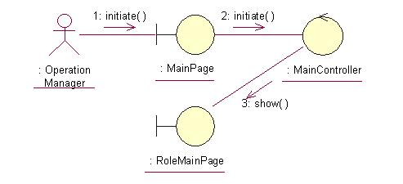
The above collaboration diagram shows the process flow after the actor has login.

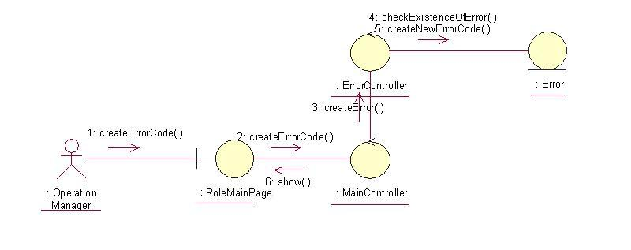
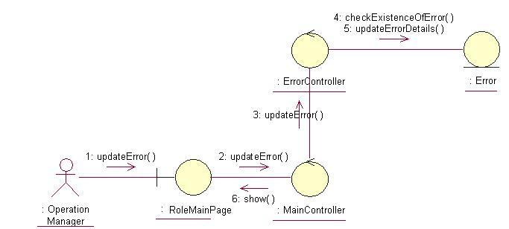

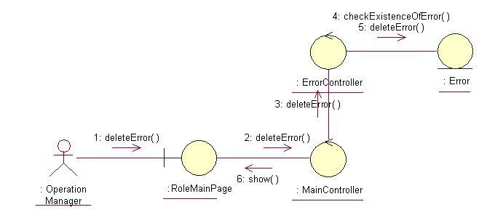
The above collaboration diagrams show the main process flows of this use case.

Participating Objects

Operation Manager
This actor represents the operation manager who will have a web page console to monitor and update the cylinder manufacturing operation.

Main Page
This object renders the contents after the actor has login. The Director, Department Manager and Operation Manager actors use this object.

Role Main Page
This object renders the contents (based on the user role) after the actor has login. The Director, Department Manager and Operation Manager actors use this object.

Main Controller
This object acts as the middleman between Main Page and the Error Controller. It will translate interactions with the view into actions to be performed by the Error Controller.

Error Controller
This object acts as the middleman between Manage Error Page and the Error object. It will translate interactions with the view into actions to be performed by the Error object.

Error
This object stores the details concerning the error of the COMS.

Class Diagrams

Domain Class Diagram: Manage Error

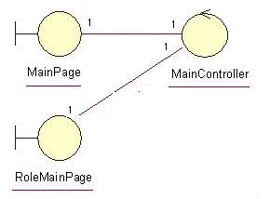
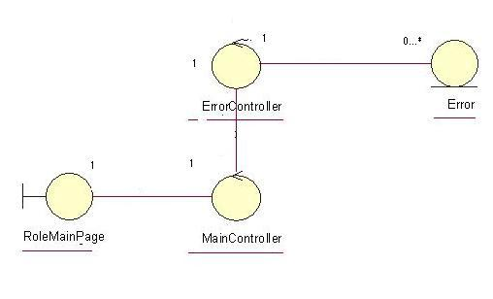

Derived Requirements
The Operation Manager PC keyboard and mouse will be used to enter error details (if any) and view all the system responses.

